Session1 Assignment 1.2

Unix Commands:

PWD : present working directory

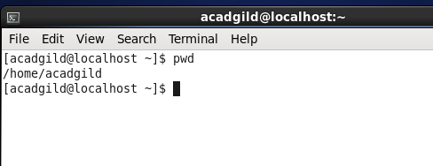

VI: 🡪 vi editor

The fundamental UNIX editor is called vi. It is a primitive editor.

There are essentially three Modes in vi,

1.Insert Mode where one is typing in new text.

2.Edit Mode where one is modifying text that is already there.

3.Command Mode where one is interacting with the operating system with actions like reading and writing files.

**INSERT Mode** - For adding text to a file:

**i**(lower case) -->Starts inserting in front of the current cursor position

**I**(upper case) -->Starts adding at the front of the line

**a**(lower case) -->Starts adding after the cursor

**A**(upper case) -->Starts adding at the end of the line

**o**(lower case) -->Starts opening a new line underneath the cursor

**O**(upper case) -->Starts opening a line above the cursor.

**<Esc>** -->Gets out of Insert Mode

**EDIT Mode** - Generally for moving the cursor and deleting stuff. -->Note: the Arrow keys do work locally, but sometimes mess up over a network.

Simple Cursor Movement:

**h** -->Moves cursor left one space

**j** -->Moves cursor down one line

**k** -->Moves cursor up one line

**l** -->Moves cursor right one space

Fast Cursor Movement:

**w** -->Moves the cursor a full word at a time to the right

**b** -->Moves the cursor back to the left a word at a time

**^** -->Moves the cursor to the front of a line

**$** -->Moves the cursor to the end of a line

**<ctrl>f** -->Moves the cursor forward a full page of text at a time

**<ctrl>b** -->Moves the cursor backward a full page of text at a time

Modifying Text:

**x**(lower case) -->Deletes the character under the cursor

**dd** -->Deletes the line where the cursor is located (type d twice!)

**n dd** -->Delete n consecutive lines ( n is an integer)

**r** -->Replaces the character under the cursor with the next thing typed

**J**(upper case) -->Joins current line with the one below (Capital J!)

**u** -->Undoes the last edit operation

**<ctrl> r** -->Redo (Undoes the last undo operation)

Cut and Paste Operations:

**yy** -->Copies or yanks a line ( 5yy yanks 5 lines)

**p** -->Puts the yanked text on the line below the cursor (lower case p)

**P**(upper case) -->Puts the yanked text above the current line (capital P)

**COMMAND Mode** - For interacting with the operating system.

To enter the Command Mode, a colon " : " must precede the actual command. --> esc :

**: r** <file> -->reads a file from disk into the vi editor

**: w** <file> -->writes current file to disk

**: wq** -->writes the file and quits vi

**: q!** -->quits without writing (useful if you've messed up!)

**vi -R /etc/shadows** --> open file in read only with -R option. Press ‘:q‘ to quit from vi window.

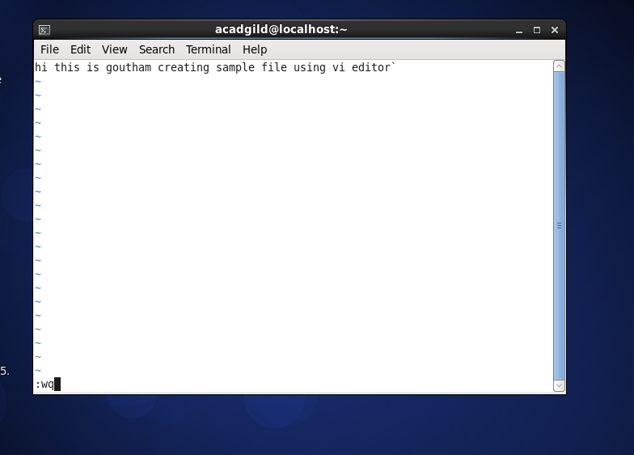

Touch: used to create a empty file.

Touch filemname

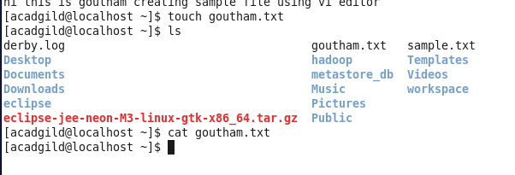

Mkdir:

Mkdir filename 🡪 create a dir with filename.

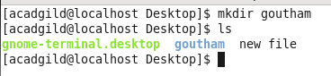

rm 🡪 remove

rm filename 🡪 removes file.

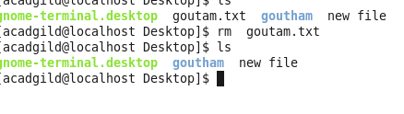

ls -> list the files

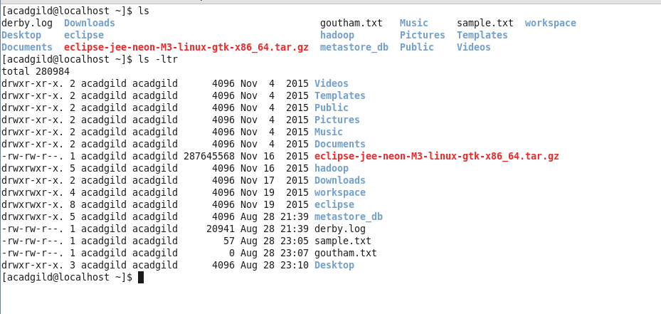

Echo 🡪 output the string which is passed as arguments to echo

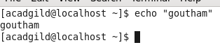

Cat 🡪 displays data

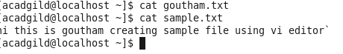

Who:

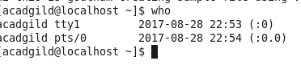

Cd -> change directory

Date 🡪 gives todays date

Cal -> displays calendar

Mv .> move file location to location or rename the file

cp -> copy one file to other new file.

Which -> which returns the pathnames of the file/links which would be executed in current environment.

